Rock, Paper, Scissors in Logic Gates

A Laboratory Project Presented to

Mr. Carlos IV Hortinela

Mapua Institute of Technology

in partial fulfillment

of the requirements in

Discrete Mathematics

(COE128) Section A3

by

Kyle Angelo G. Alelis

Kenneth D. Chan

Heinz Alfred Q. Juan Tong

December 2016

**Acknowledgements**

This laboratory project primarily applies the knowledge of formal logic in the common game of rock, paper, scissors. Even though the students find this project a bit taxing in time, money and brainpower, they have managed to accomplish the task in the limited time available. This is also caused by the support of key individuals and as such, the students would like to acknowledge:

Their parents, that gave their support, effort and some money for the project.

Mr. Carlos IV Hortinela, for teaching the students about the basics of formal logic and integrated circuits and for giving the students this project.

Finally, God, for the blessing and guidance that granted the students the resolve to accomplish this project.

K.A.G.A.

K.D.C.

H.A.Q.J.T.

**Table of Contents**

TITLE PAGE

ACKNOWLEDGEMENT

TABLE OF CONTENTS

LIST OF FIGURES

ABSTRACT

Chapter 1: PROJECT BACKGROUND AND INTRODUCTION

Definition of Terms

Chapter 2: PROJECT METHODOLOGY AND PROCEDURES

Chapter 3: TESTING, PRESENTATION, AND INTERPRETATION OF DATA

Purpose

Procedure

Analysis

Chapter 4: CONCLUSION AND RECOMMENDATION

APPENDICES

Data sheets

The Design Project

User Manual

BIBLIOGRAPHY

**Abstract**

In order to monitor if the students’ learning in the discrete mathematics course, this project was assigned to the students by the instructor. This project was brought to life in order to apply the students’ knowledge about the theories and concepts of formal logic and integrated circuits. This report breaks down the details of the said project and explains the components and workings of the design project the group of students came up with. The data (i.e. truth tables, data sheets of circuits, etc.) were gathered either from the web or the class discussions in COE128 or the discrete mathematics course. There were some problems in the overall truth table and schematic of the design, setbacks and numerous broken parts due to misuse. However, in the end the group managed to accomplish the said design. Future students who wish to take on the concept of rock, paper, scissors as their design project should consider making the design and circuit a bit simpler in order for it to be less costly and more visually understandable.

***Keywords:*** discrete mathematics, project, formal logic, integrated circuits

**Project Background and Introduction**

Nowadays, numerous games for entertainment are brought about by formal logic. Specifically, one of the most used formal logic game application is the hierarchical cycle of Rock, Paper, Scissors (henceforth, RPS) which was created in China way back during the Han dynasty [1]. This cycle depicts that all elements are equally powerful in the hierarchy where each element is fully capable of either trumping or succumbing against another. RPS is the simplest form of hierarchical cycle which later on breeds games that uses type to measure effectivity like Pokémon or board games that also have this kind of logic like Game of the Generals.

RPS is a simple game in which rock breaks scissors, scissors cut paper, and paper covers rock. However, if converted into a circuit, it can yield many different forms when utilizing different logic gates.

With these in mind, the group aims to:

1. Understand the logical concept of RPS.
2. Find the simplest possible circuit for the concept of RPS.
3. Create a working design of RPS using integrated circuits.

The project is a limited resource thus, only includes all the necessary tests and data in order to fulfill the objectives above. This means that truth tables of logic gates, circuit diagrams, integrated circuit (henceforth, IC) data, and design specifications are all included. However, the paper does not expound on the workings of games that used the concept of RPS.

*Definition of Terms:*

* **RPS**- Rock, Paper, Scissors
* **IC**- Integrated Circuit
* **Tact switch**- switch that momentarily reacts to the user only when pressed
* **6pin push-and-lock switch-** switch that has an off and on state
* **7805-** voltage regulator that turns 9-volts to 5-volts
* **LED**- Light Emitting diode used to display the result of a clash
* **Clash**- a round of RPS
* **7408**- Quad 2-input AND gate IC
* **7432**- Quad 2-input OR gate IC
* **7486**- Quad 2-input XOR gate IC
* **7404**- Hex Inverter

**Project Development Procedures**

**Testing, Presentation, and Interpretation of Data**

**Purpose**

The purpose of the test is for us to know if we are able to create a game of rock, paper, scissors with what we have learned in COE128. The application logic gates to be exact. Logic gates play a big part in this project and is actually the core of this project. First of all, we want to test our knowledge in logic gates and we want to apply them in this game. We also want to test our skills in using bread boards, wires etc. The main purpose of our test to find out if our project actually works and find out of an actual rock paper, scissors game can happen.

**Procedure**

First of all, we check if all wires are wired properly, especially the resistors because the moment we plug in the power there could be a voltage overload which could damage the components of our circuit. When we have made sure that everything is in place, we affix the battery to the battery holder. Each side would choose their choice and a switch would be flicked to see who won, a red light would mean that player 1 has won, a green light would mean that player to has won and blue light would mean that there is a draw.

**Analysis**

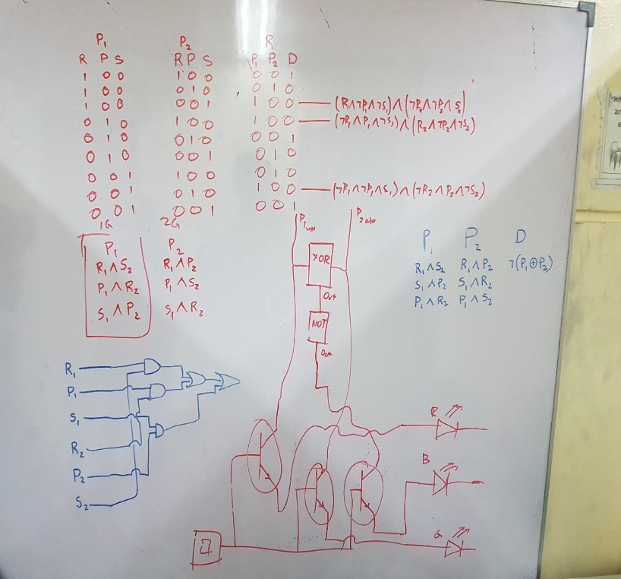

*Figure (1)*

According to our data in figure 1, The truth table consists of 6 different inputs and 3 for each player. Among the 64 different possible input combinations, we only considered 9 inputs in which a player chooses only 1 input. The three columns under results (R) shows the different outputs that shows which player won the clash or the clash came to a draw. We used AND gates to compare the choices of each player. Since there are different cases where one of the player wins, these cases will then pass through the OR gates to decide which light will turn on. The draw however, is brought about XNOR. If neither player won, it means it is a draw so we used an XOR IC to determine if one of the lights are on. Then we negate it using an inverter to produce the system where if neither the red nor the green LED are on, the blue LED is turned on to signify a draw.

**Conclusion and Recommendation**

Overall, the project has guided the group in reaching a n acceptable conclusion to their objectives. The game of RPS is a type of game which uses a hierarchical cycle. The logic in the game is about comparing the inputs of the two players and deciding which among the two players become the victor. Having this in mind, the simplest circuit that the group came up with composes of 6 inputs, 3 for each player’s rock, paper, and scissors which are compared by 7408, 7432, and 7486 ICs. With those materials, the group managed to make a working design that plays the game of RPS.

Future student who would like to take up the concept of RPS should consider finding simpler circuits for RPS. Furthermore, they can also look more into the more complex hierarchical cycle type games that have either more than 3 inputs per player or more than 2 players. In short, study the games that also use the concept of RPS.

**Appendix**

**-Data sheets:**

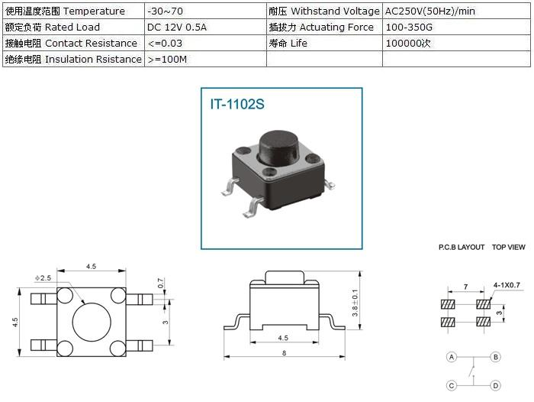

[2]

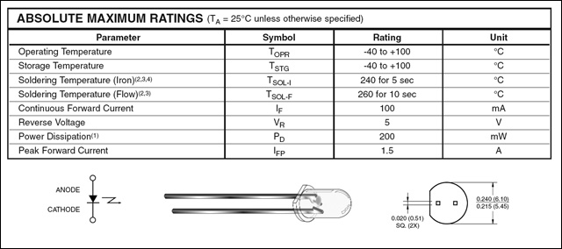

[3]

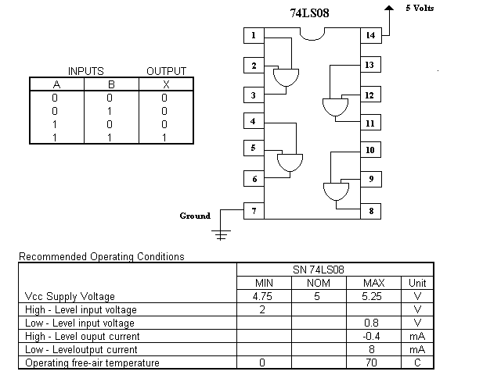

[4]

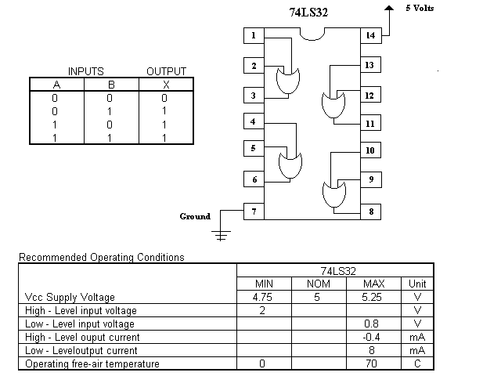

[[5]](http://guweb2.gonzaga.edu/faculty/walsh/CPEN130L/7432.GIF)

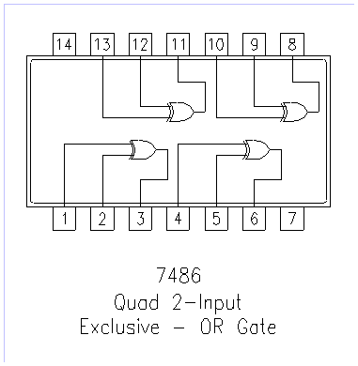

**Recommended Operating Conditions**

|  |  |  |  |  |  |
| --- | --- | --- | --- | --- | --- |
| **Symbol** | **Parameter** | **Min** | **Typ** | **Max** | **Units** |
| Vcc | Supply Votage | 4.75 | 5 | 5.25 | V |
| Vih | HIGH Level Input Voltage | 2 |  |  | V |
| Vil | LOW Level Input Voltage |  |  | 0.8 | V |
| Ioh | HIGH Level Output Current |  |  | -0.4 | mA |
| Iol | LOW Level Output Current |  |  | 16 | mA |
| Ta | Free Air Operating Temperature | 0 |  | 70 | °C |

[6]

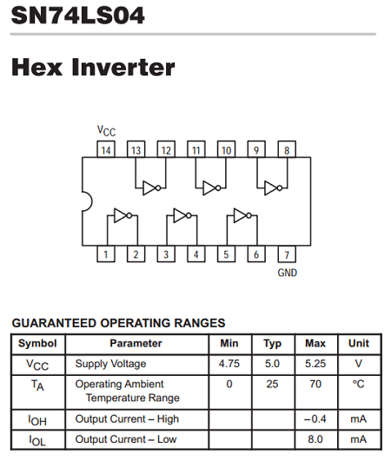

[[7]](http://www.datasheetcafe.com/74ls04-datasheet-pdf-7404/)

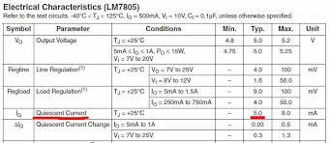

[8]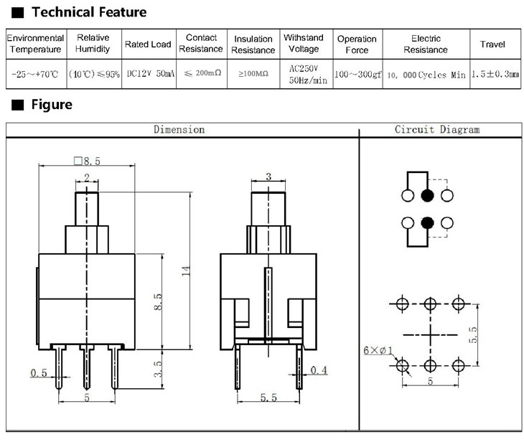

[9]

**-The Design Project:**

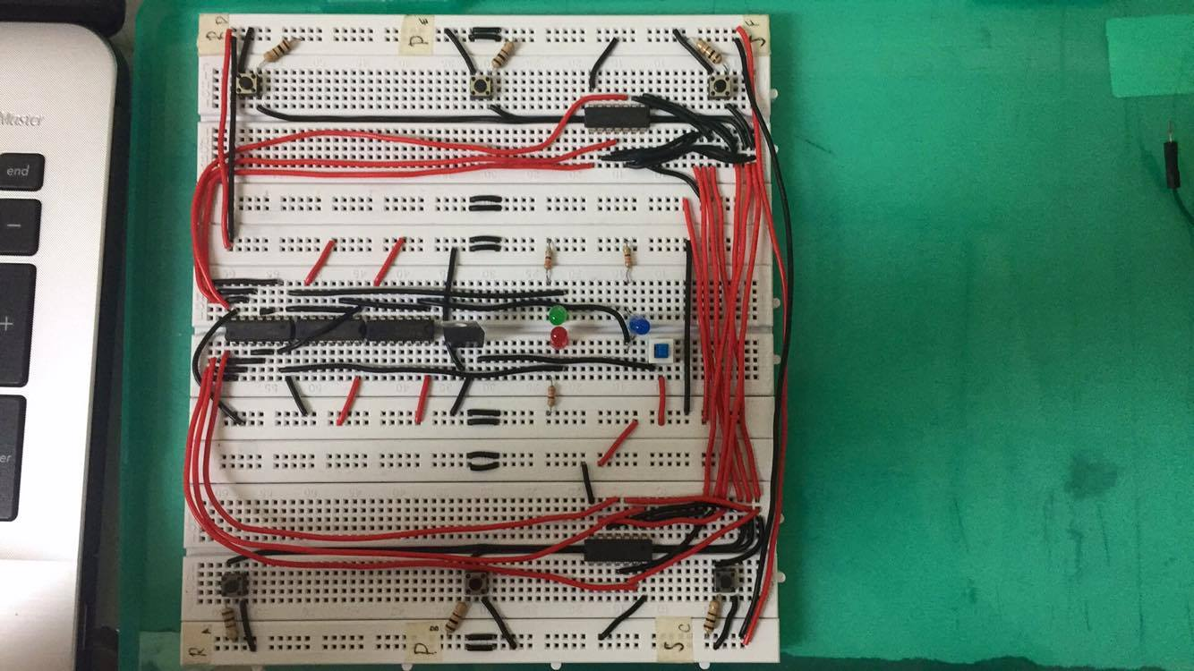

**-User Manual:**

1. Connect the device to power (i.e. 9V Battery)
2. The left button is rock, middle is paper, and right is scissors.
3. Players clash by choosing an input.
4. Players simultaneously press and hold their chosen inputs.
5. The 6 pin push-and-lock switch is to be pressed in order to decide the clash.
6. Players observe the results of their clash dictated by the LED that is on.
7. Red LED means player 1 wins, Green LED means player 2 wins, Blue LED means draw.
8. Players release their hold on the input switches and press the 6pin switch again to stop decision making.
9. Repeat process from step 3-7 until players are tired of the game.

**Bibliography**

[1] Moore, M. E., Sward, J. (2006). *Introduction to the game industry*. Upper Saddle River, NJ: Pearson Prentice Hall. p. 535. [ISBN](https://en.wikipedia.org/wiki/International_Standard_Book_Number) [978-0-13-168743-1](https://en.wikipedia.org/wiki/Special:BookSources/978-0-13-168743-1).

[2] IT-1102S data sheet. [http://jstar-elec.com](http://jstar-elec.com/parts/datasheet/M5/DS_IT-1102S.jpg). Retrieved 14 Dec. 2016, from <http://jstar-elec.com/parts/datasheet/M5/DS_IT-1102S.jpg>.

[3] 3mm Super bright LED data sheet. <http://www.lucidscience.com>. Retrieved 14 Dec. 2016, from [http://www.lucidscience.com/propulsed%20led%20illumi nator-2.aspx](http://www.lucidscience.com/propulsed%20led%20illumi%20nator-2.aspx).

[4] 7408 Quad 2-input AND IC data sheet. [http://guweb2.gonzaga.edu](http://guweb2.gonzaga.edu/faculty/walsh/CPEN130L/7408.GIF). Retrieved 14 Dec. 2016, from [http://guweb2.gonzaga.edu/faculty/walsh/CPEN130L /7408.GIF](http://guweb2.gonzaga.edu/faculty/walsh/CPEN130L%20/7408.GIF).

[5] 7432 Quad 2-input OR IC data sheet. [http://guweb2.gonzaga.edu](http://guweb2.gonzaga.edu/faculty/walsh/CPEN130L/7432.GIF). Retrieved 14 Dec. 2016, from [http://guweb2.gonzaga.edu/faculty/walsh/CPEN130L /7432.GIF](http://guweb2.gonzaga.edu/faculty/walsh/CPEN130L%20/7432.GIF).

[6] 7486 Quad 2-input Exclusive OR IC data sheet. http://www.futurlec.com. Retrieved 14 Dec. 2016, from http://www.futurlec.com/74/IC7486.shtml.

[7] 7404 Hex Inverter IC data sheet. [http://www.datasheetcafe.com](http://www.datasheetcafe.com/74ls04-datasheet-pdf-7404/). Retrieved 14 Dec. 2016, from <http://www.datasheetcafe.com/74ls04-datasheet-pdf-7404/>.

[8] 7805 Voltage regulator data sheet. <https://www.insidegadgets.com>. Retrieved 14 Dec. 2016, from https://www.insidegadgets.com/wp-content/uploads/2011 /01/lm7805-q.jpg

[9] 6pin push-and-lock switch data sheet. http://g02.s.alicdn.com. Retrieved 14 Dec. 2016, from http://g02.s.alicdn.com/kf/HT1H2dDFP8cXXagOFbXk /200038722/HT1H2dDFP8cXXagOFbXk.jpg